**Exercise 1**

1. List all data stored in the table PRESIDENT

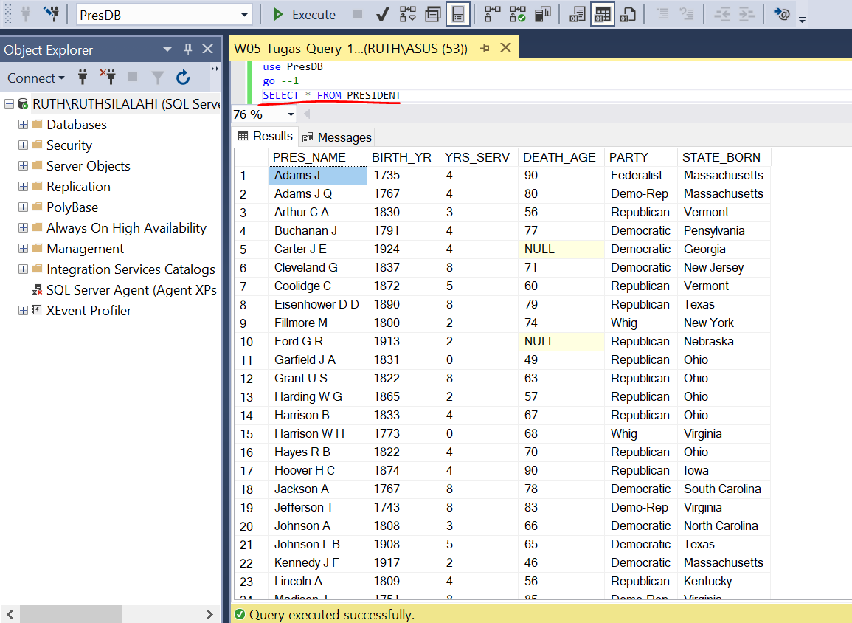

1. List all president data was born on Massachusetts, New York, and Texas state.

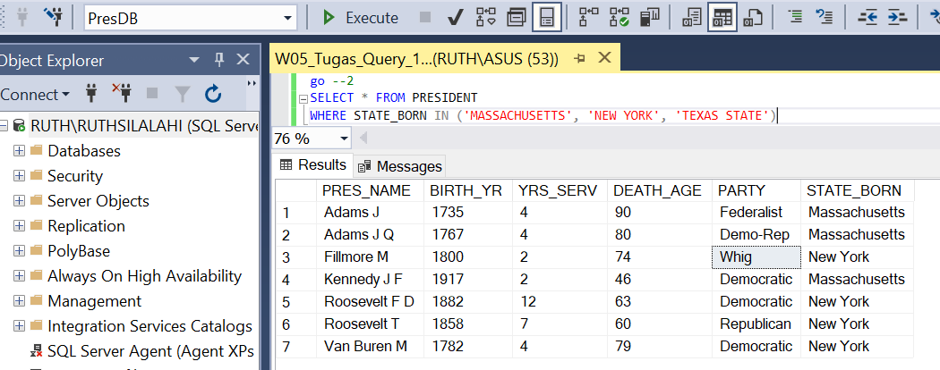

1. List all president data which did not die yet (as far as registered)

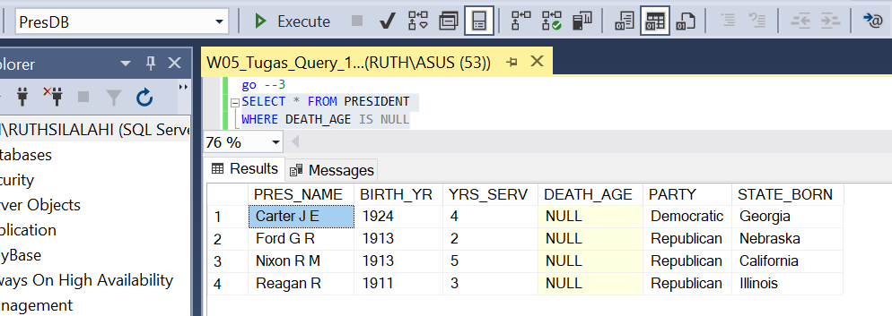

1. List all election data, ordered by election year, about the winners of the presidential elections on 20th century.

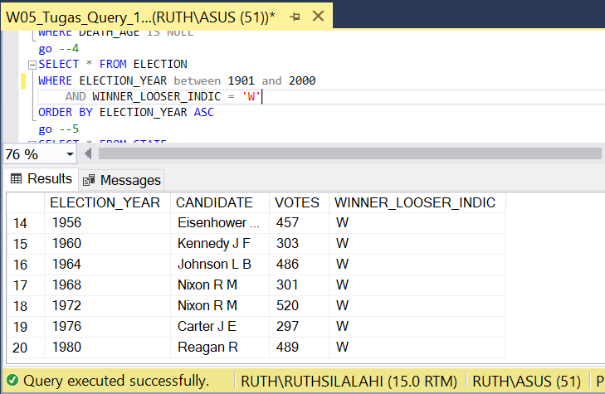

1. Which states entered the USA in which year during the 19th century? The 19th century (January 1, 1801 – December 31, 1900)

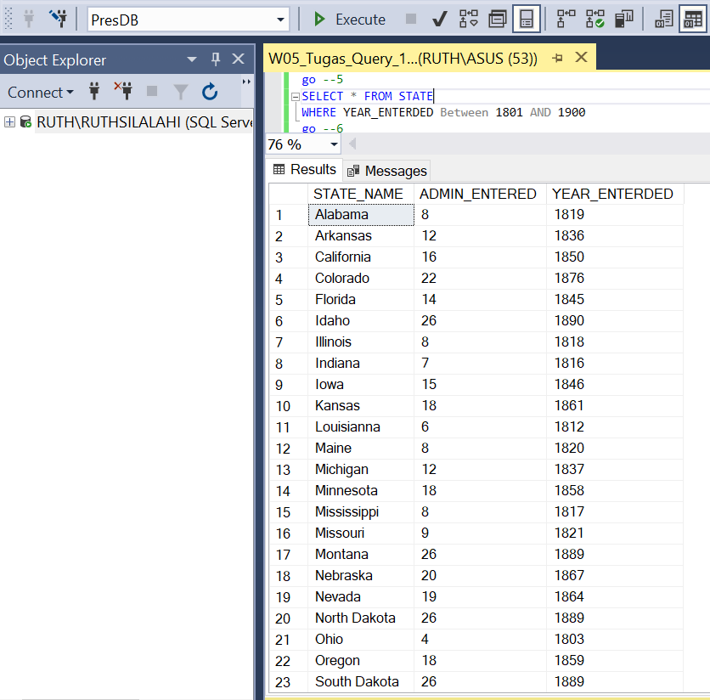

1. List in alphabetic order the names of presidents who's names have an 'e' as second character.

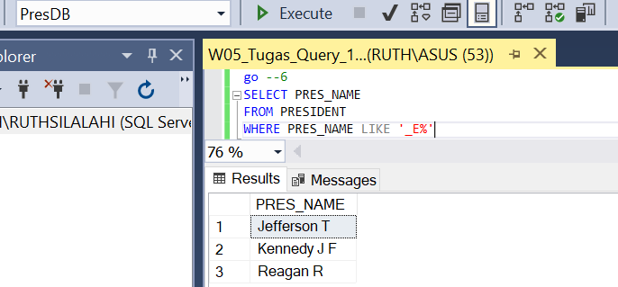

1. Give all registered data about those non childless presidential marriages, where at least one of the partners was 'older than 40' at marriage.

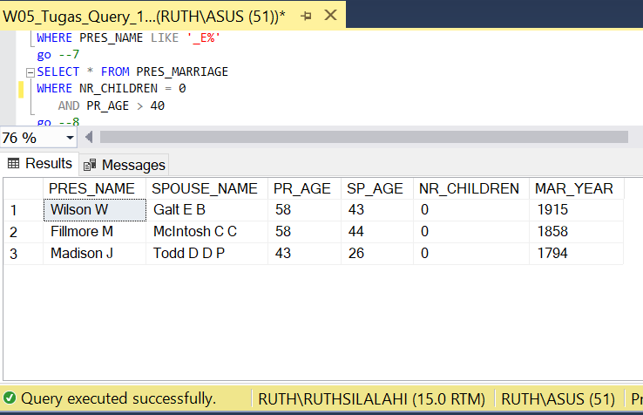

1. Which losers of presidential elections got a number of votes between 150 and 250 stemmen? Give also the election years of those elections.

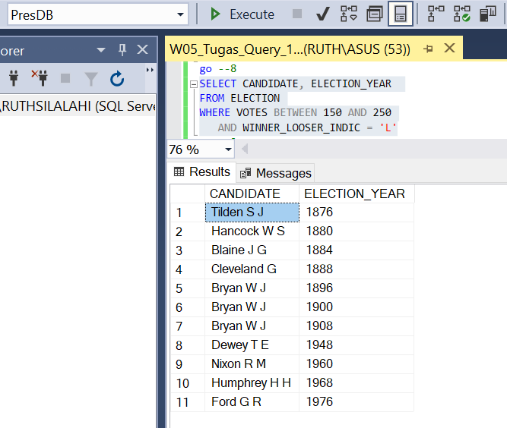

1. From a crossword puzzle: Which presidents have a 'C' or a 'K' as the first letter of their family name and an 'O' as the third letter?

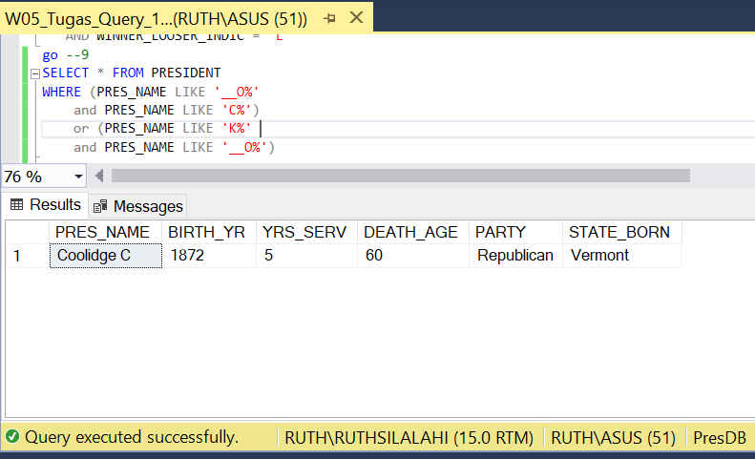

1. List all data about administration (president and vice president) that the vice president name is not contain bush or character ‘b', 'u', 's', 'h'

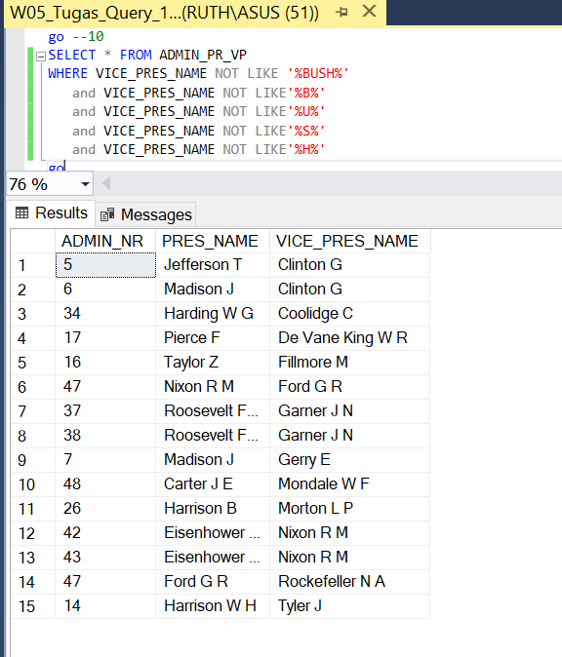

**Exercise 2**

1. Give the highest, lowest and average death ages of already died presidents.

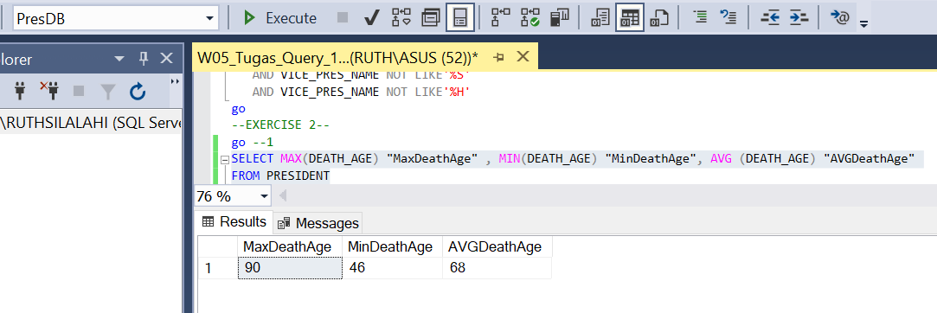

1. In how many states presidents were born?

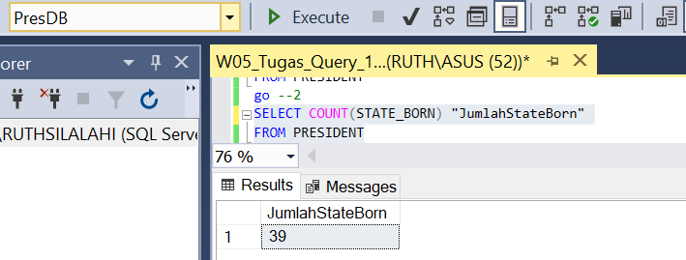

1. For each state in which more than one president was born, count the number of democratic presidents born in that state. Order in descending order on those numbers and than alphabetically by state names.

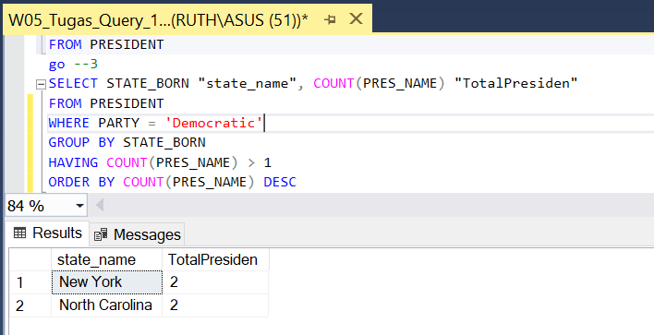

1. Give for all married presidents the number of their marriage and the total number of children of all their marriages who has at least two child.

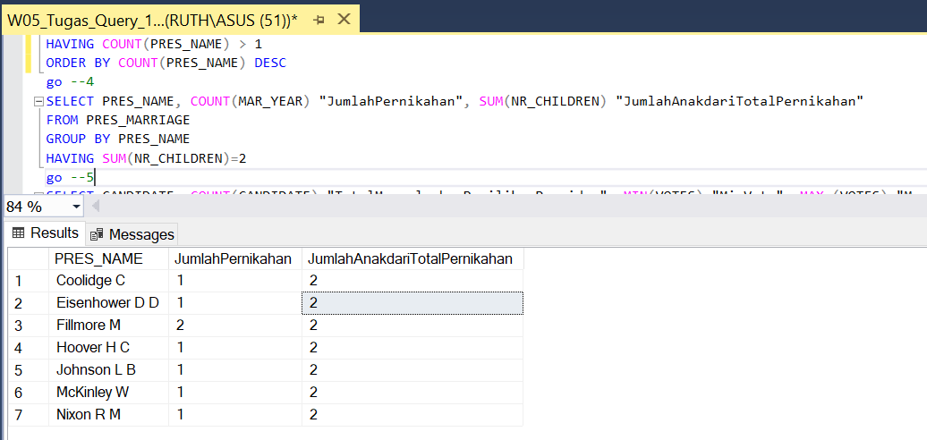

1. Give for the candidates who participated at least twice for presidential elections, their minimum and maximum number of votes.

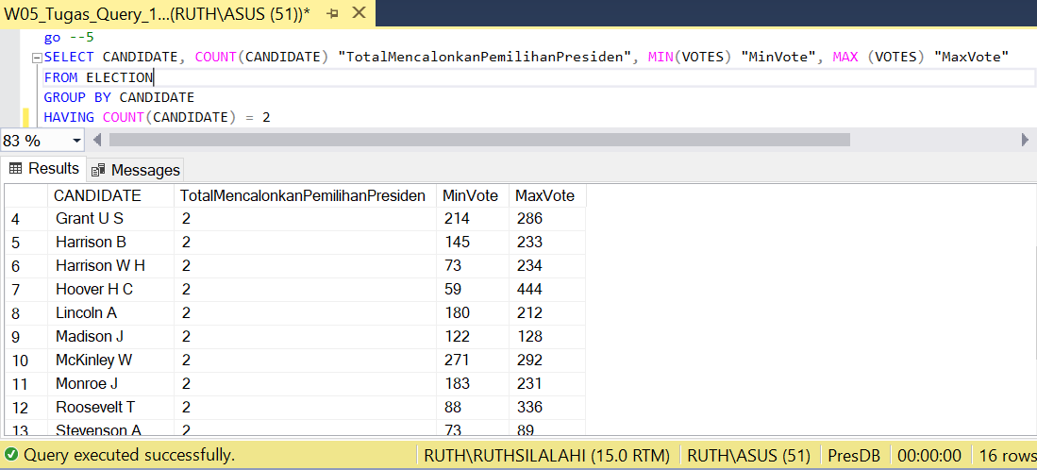

1. Give the percentage of votes of the candidate who got most votes in 1960.

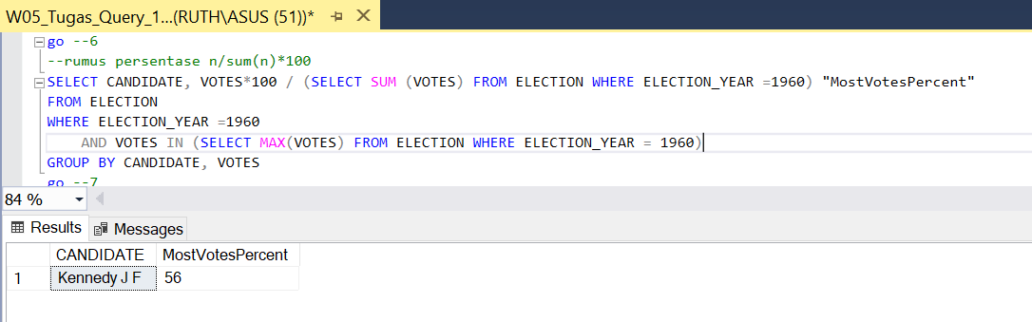

1. Which presidents married more than once and how many times did they marry?

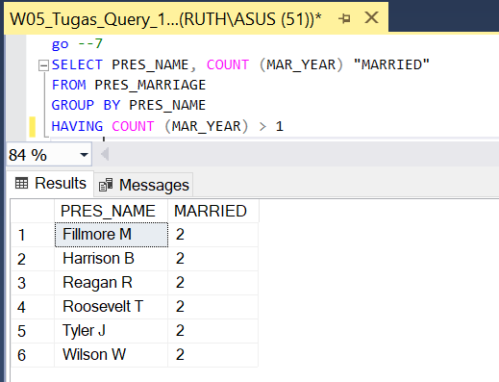

1. What is the average death age of the already died presidents?

